**Departmental Report**

**Department of Chemistry**

**Session 2023-24**

**Department at a glance**

The department of Chemistry was established in 1959 and since then it is flourishing continuously. The department comprise of seven regular faculties and three guest faculties led by head of the department Prof. Younus Raza Beg. Dr. Dakeshwar Kumar Verma, Dr. Priyanka Singh and Dr. Ashwani Kumar Sharma have been thriving in their areas of research as PhD. guides. The department offers various graduate and post-graduate courses under which the graduation courses are in both annual and semester system after the implementation of NEP-2020.

**Departmental achievements**

From time to time, in order to foster awareness among the students, career guidance lectures are being organised in which expert faculties guide students about the scope in the field of Chemistry. A guest lecture on career guidance was organised on April 20,2023 in which the keynote speaker were Dr. Rahul Diggikar, Professor, Department of Chemistry, New Arts, Commerce and Science college, Parner, Ahmednagar, Maharashtra. In this series another lecture was organised on July 19, 2023in which the guest speaker were Dr. Rajmani Patel, assistant registrar, Hemchand Yadav University, Durg.A third in the series was a lecture by Dr. Alok Mishra, Principal, Govt. Kamla Devi Rathi college, Rajnandgaon (C.G.). Emphasising on the career opportunities in the field of Chemistry, a lecture by Dr. A.K. Jha, Assistant Professor, Department of Chemistry, Govt. Shivnath Science college, Rajnandgaon (C.G.).

**Departmental activities**

One week pre-placement workshop

From time to time various activities are being organised by the department for the holistic development of the students focusing on their academic, personality and career’s growth.A one week per-placement workshop was organised from May 1, 2023 to May 6, 2023 by the department for the postgraduate students to mould them perfectly in every aspect be it group discussions or interview in order to take the campus placements. This workshop was organised not only for the postgraduate students of our college but also for the aspiring students of the colleges in MoU with our institution.

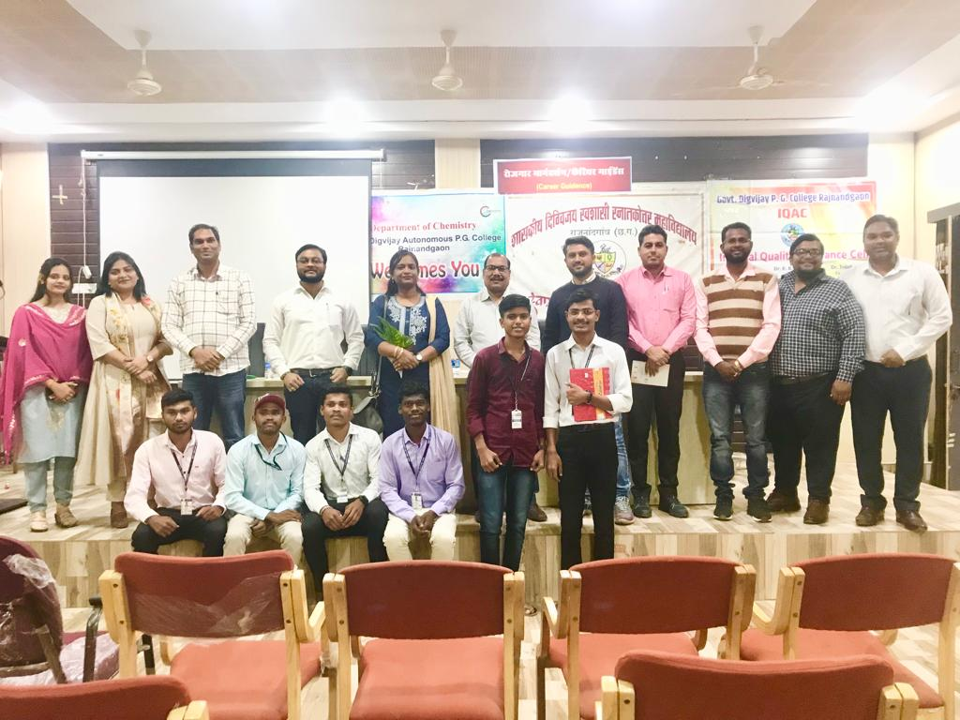

Visit to MSME

Under the MoU signed with the MSME, Rasmadha, Durg (C.G.) the students visited the centre for a one day workshop on the instruments and software training and study tour. Our students were greatly benefited by this initiative.

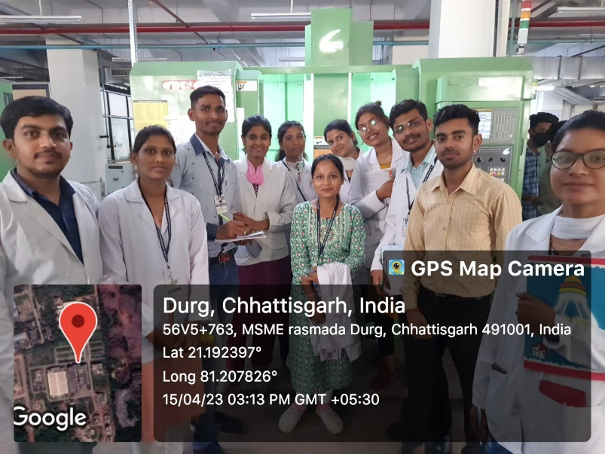

Plantation and cleanliness drive

A cleanliness and plantation drive was organised by the students of the department with the aim to create an Oxy-zone by planting the saplings of tulsi in the premises of the department.

**Teacher’s Day**

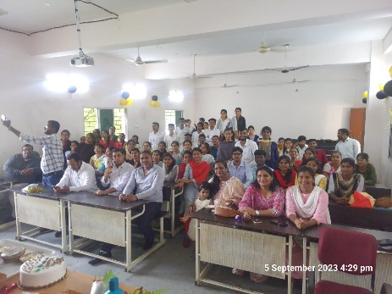

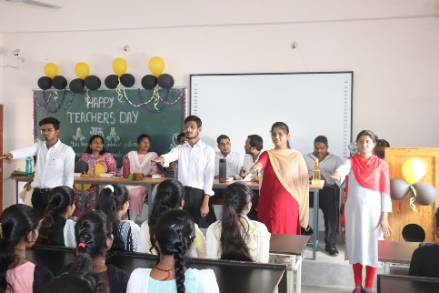

**Extension activity**

Visit to Sugar factory

In order to make the students understand how a factory actually works, we visited the Bhoramdeo Sugar factory, Kabirdham as a part of the extension activities offered by the department. The students observed the whole process of manufacturing of sugar from sugarcane ams also the processing of sugar. They also visited the famous and ancient Bhoramdeo temple.In addition to being a knowledgeable trip it also served as a chance to strengthen the student-teacher bond.

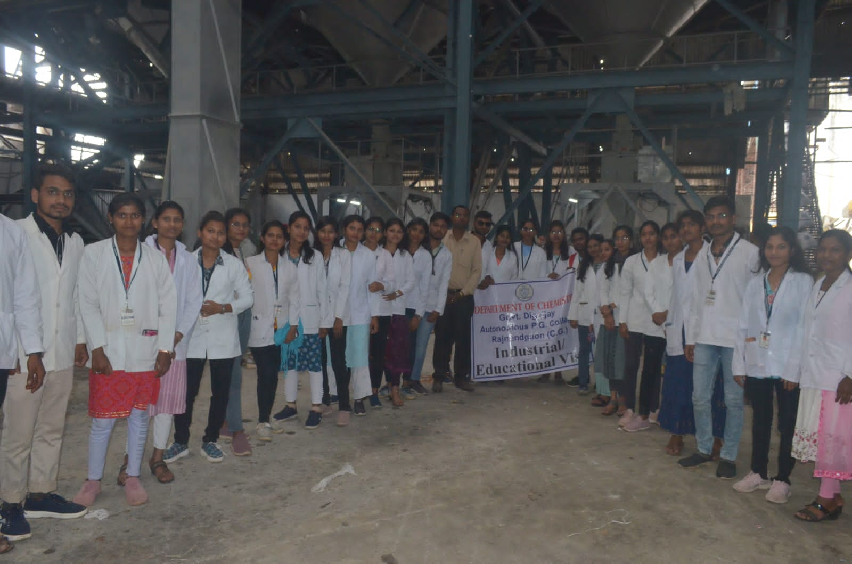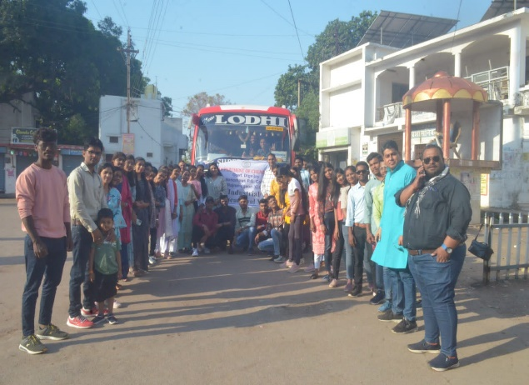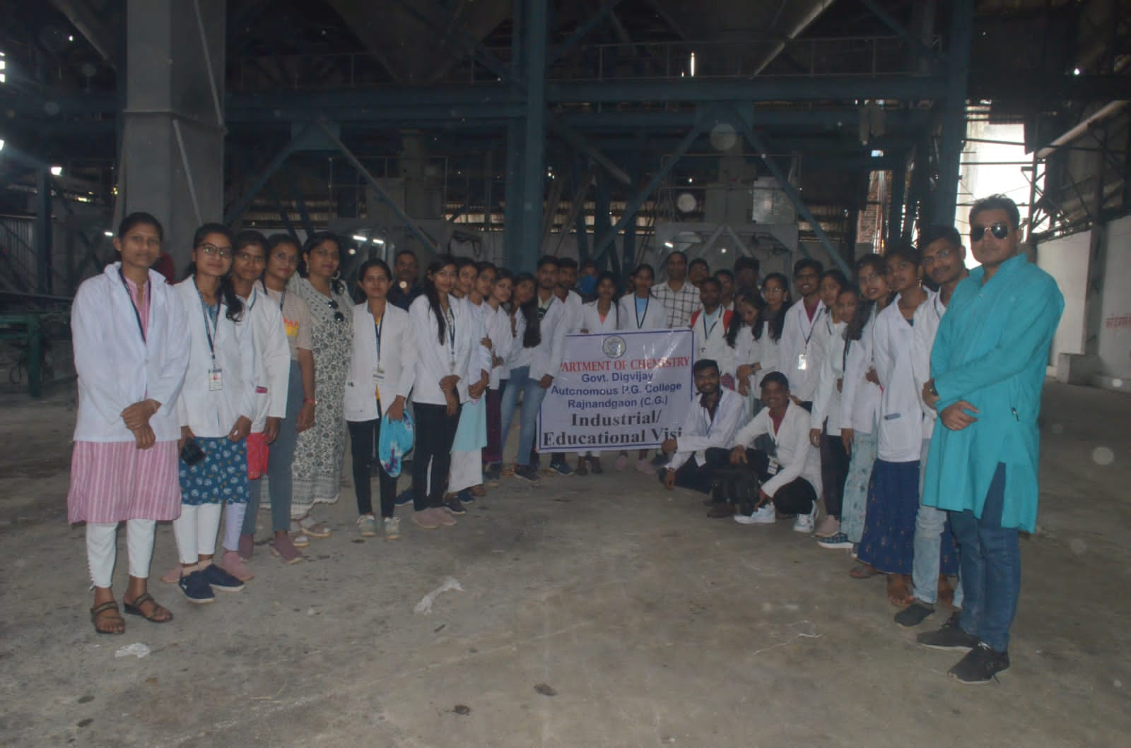

NEP-2020-Extension activity

Under the extension activity, the students visited the Govt. Higher Secondary School in Tedesera. A lecture cum presentation was delivered by Dr. Ashwani Kumar Sharma on the NEP-2020. Later a nukkad natak, with a theme revolving around the Viksitbharat@2047 was presented by the students.

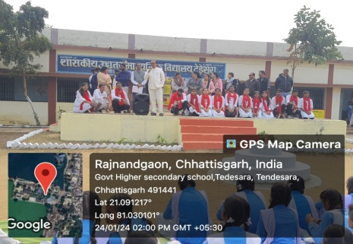

**Special lecturers**

Special lectures are classified as lectures in which persons from reputed institutions visit our college and they talk about their institutions, work culture and employment opportunities with our students in order to open insights in this field. One such lecture was organised on August 28, 2023 in which a team of experts from CIPET- Raipur has visited our institute. The keynote speakers were Mr.Vibhor Sahu, assistant professor and Mr. Devendra Kulbhuje, assistant professor at the same institute. They discussed in detail about the chemistry of plastic, opportunities for studying and jobs both.

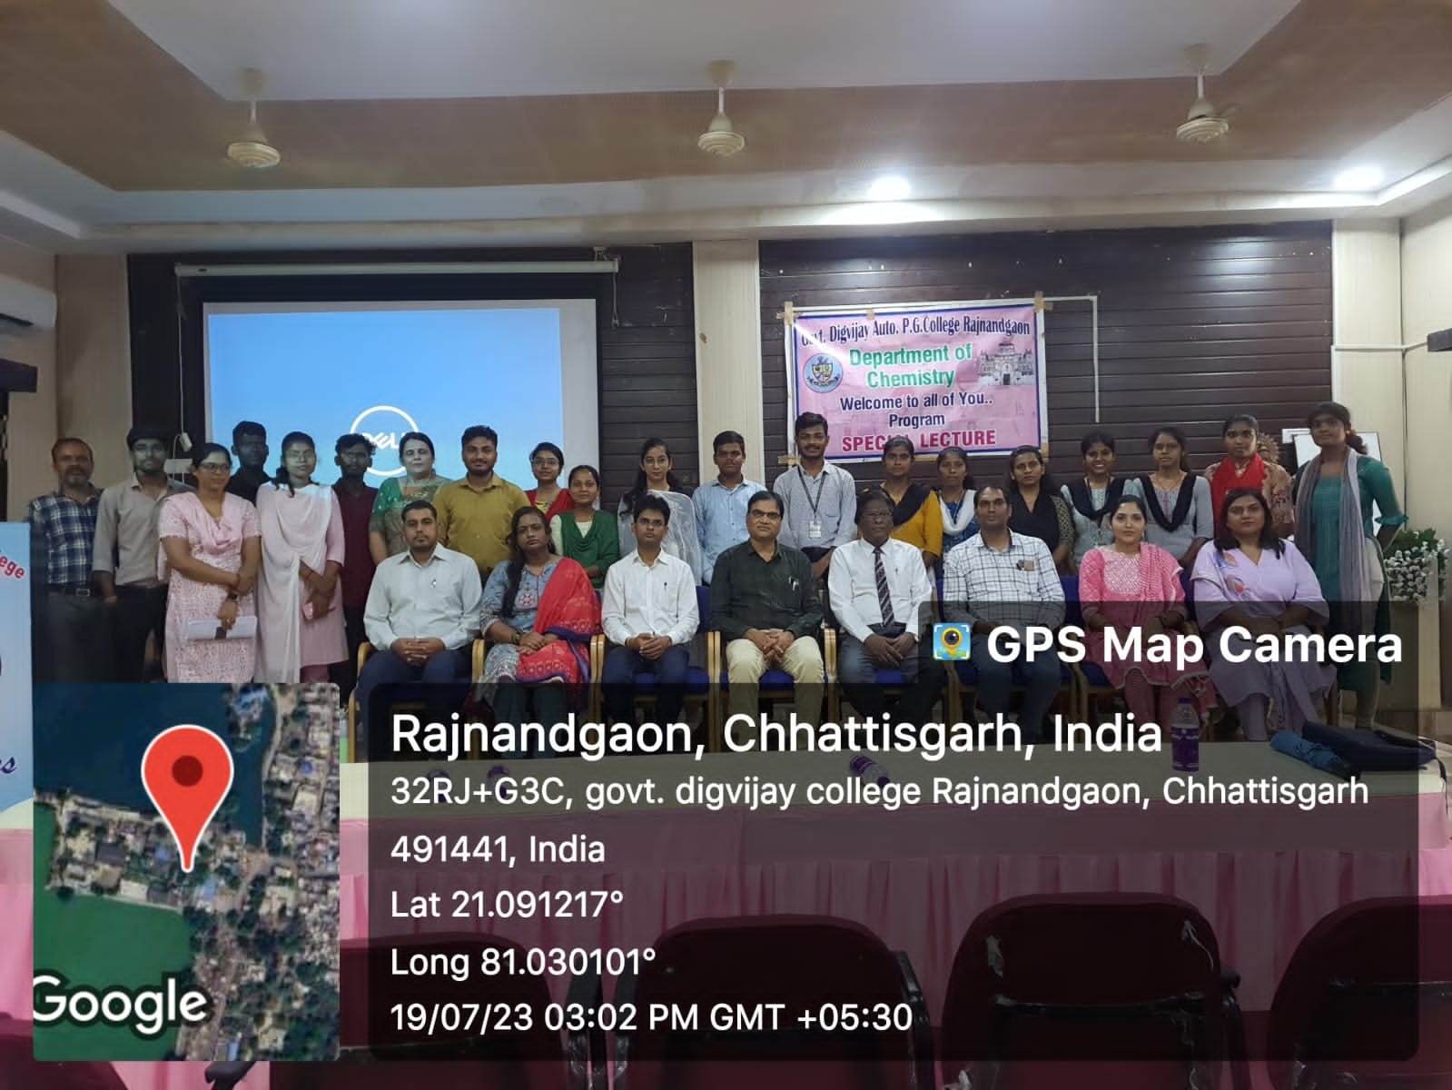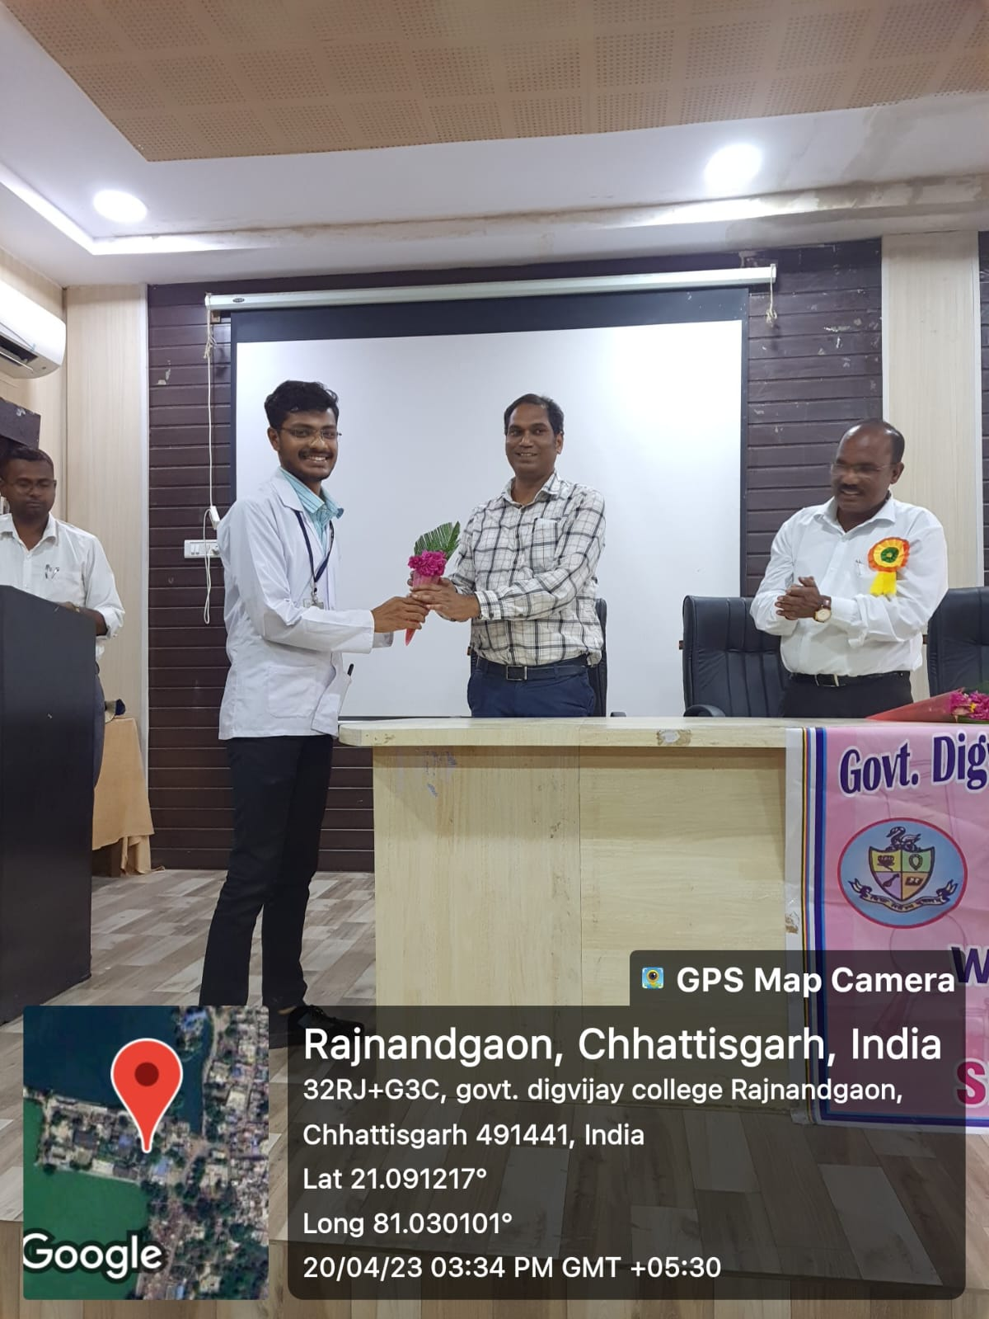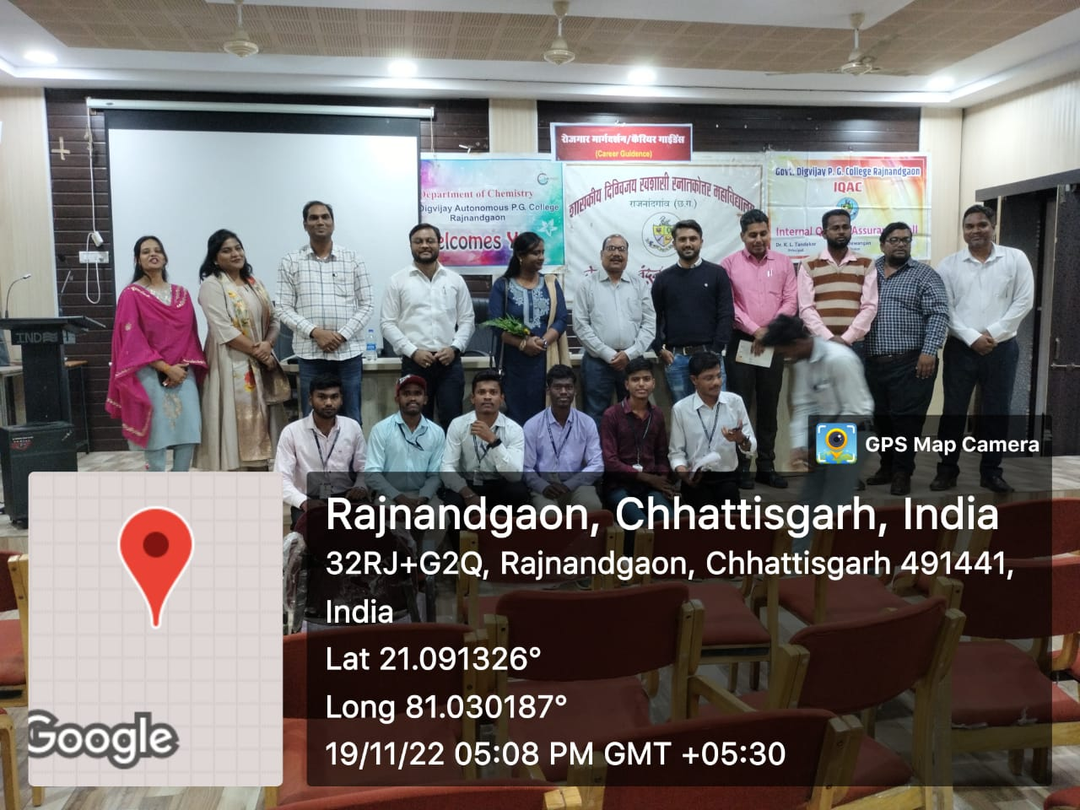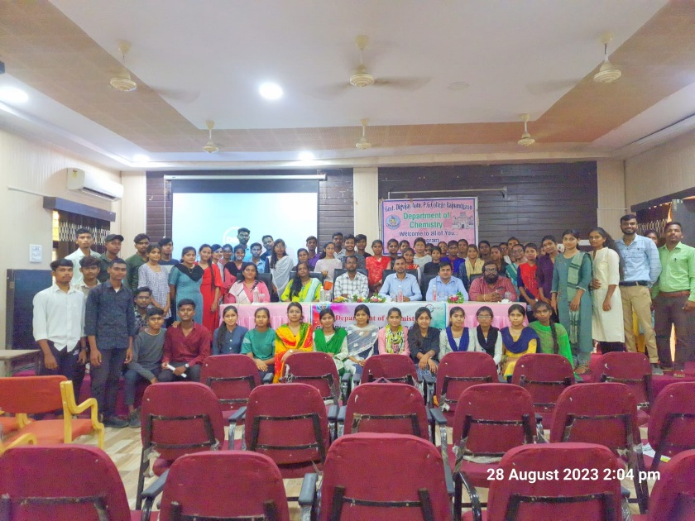

**Interdepartmental guest lecture**

Interdepartmental guest lectures are organised for the students from time to time so that the expertise of other subjects can be experienced by the students of our department. In this series, a lecture by Mrs. Priyanka Das from the computer science department was organised in which she discussed the programming languages with the students. Another lecture by Mr. Ramavatar was delivered in which he elaborately discussed about Python and some software.

**Departmental students’ achievements**

Consecutive 2rd and 3rd won by the students in poster presentation at the, “Increasing Importance of Science and Technology in Foreign Policy” organised by the Department of Chemistry, Guru Ghasidas Central University, Bilaspur on February 20-21, 2024.

**Research work and publications**

The faculties apart from indulging in academics also are involved in research works. Various research papers, review articles, books and book chapters are being published in journals of repute and renowned publications respectively. A total of six books have been co-authored by Dr. Dakeshwar Kumar Verma, the titles and publications of which are as follows:-

Books

|  |  |  |
| --- | --- | --- |
| S.No. | Title of the book | Publication |
| 1. | Advanced anti-corrosive materials | Taylor and Francis |
| 2. | Biosorbents: Diversity, Bioprocessing and Applications | Taylor and Francis |
| 3. | Green chemical synthesis with Microwaves and Ultrasound | Wiley-VCH GmbH |
| 4. | Marine molecules from Algae and Cyanobacteria | Elsevier |
| 5. | Heavy Metals: Global Pollution update and Recent Management Series | ACS Symposium Series Book |
| 6. | Carbon Dots in Biology: Synthesis, Properties, Biological and Pharmaceutical Applications | De Gruyter |

Research Papers

Apart from the book’s publication various book chapters also have been written. A total of 22 book chapters have been authored by the faculties in books of celebrated publications. In this session, 15 research papers have been published in journals of high impact factor which are as follows

|  |  |  |
| --- | --- | --- |
| Name of the faculty | Title of the paper | Publication journal |
| Dr. Ashwani Kumar Sharma | Isolation and Chemical Structural Elucidation of Antibacterial Bioactive Compounds from Endophytic Fungal Strain *Phoma sp.* D1 | Springer International Publishing |
| Dr. Ashwani Kumar Sharma | The SARS-CoV-2 variant and its multiple sub-lineages: transmissibility, antiviral drugs, monoclonal antibodies, and strategies for infection control-a review | ChemistrySelect |
| Dr. Ashwani Kumar Sharma | Density Functional theory(DFT)-based molecular modelling | Elsevier |
| Dr. Priyanka Singh | Carbon dots Nanoparticles : promising breakthrough in bio sensing, catalysis, biomedical and authers application | Elsevier |
| Dr. Priyanka Singh | A review on the determination methods of nitrate and the routes for its removal from environmental samples |  |
| Dr. Dakeshwar Kumar Verma | Principles and Theories of Green Chemistry in the Service of Corrosion Science and Engineering: Design and Application | Green Chemistry |
| Dr. Dakeshwar Kumar Verma | Electrochemical and DFT Studies of the PistaciaIntegerrima Gall Extract: An Eco-friendly Approach towards the Corrosion of Steel in Acidic Medium | ACS omega |
| Dr. Dakeshwar Kumar Verma | Integrating experimental and theoretical studies in the development of a novel alginate-based bio-composite for copper anticorrosion in 3.5% NaCl environments | International Journal of Biological Macromolecules |
| Mrs. Reema Sahu | Isatin is a new core in the developing of corrosion inhibitors: A comprehensive review | Journal of Molecular Structure |

Patent

A patent has been published entitled, “NICOTIN HYDROXAMICACIDAS AN EFFECTIVE AND ENVIRONMENTALLY ACCEPTABLE CHELATING CORROSION INHIBITORIN THE GAS AND OIL INDUSTRY: EXPERIMENTAL, SURFACE AND COMPUTATIONAL STUDIES” in the field of Polymer Technology by Dr. Dakeshwar Kumar Verma, assistant professor, Mrs. Reema Sahu, assistant professor and Mr. Yeestdev Dewangan, research scholar.